Power on the robotic arm and connect to it via the terminal.

I.Modifying the Baidu Gesture Recognition APP_ID Information for Gesture Actions

1. Open the gesture recognition action file:
nano /home/jetson/colcon_ws/src/dofbot_gesture/gesture_action.py

2.Scroll down to locate the `start_gesture` function; find the section containing the APP_ID information and replace it with the Baidu ID details you have obtained. If you are unsure how to apply for an ID, please refer to the documentation for the "Gesture Recognition" lesson.

3. Press Ctrl+S to save, then press Ctrl+X to exit.
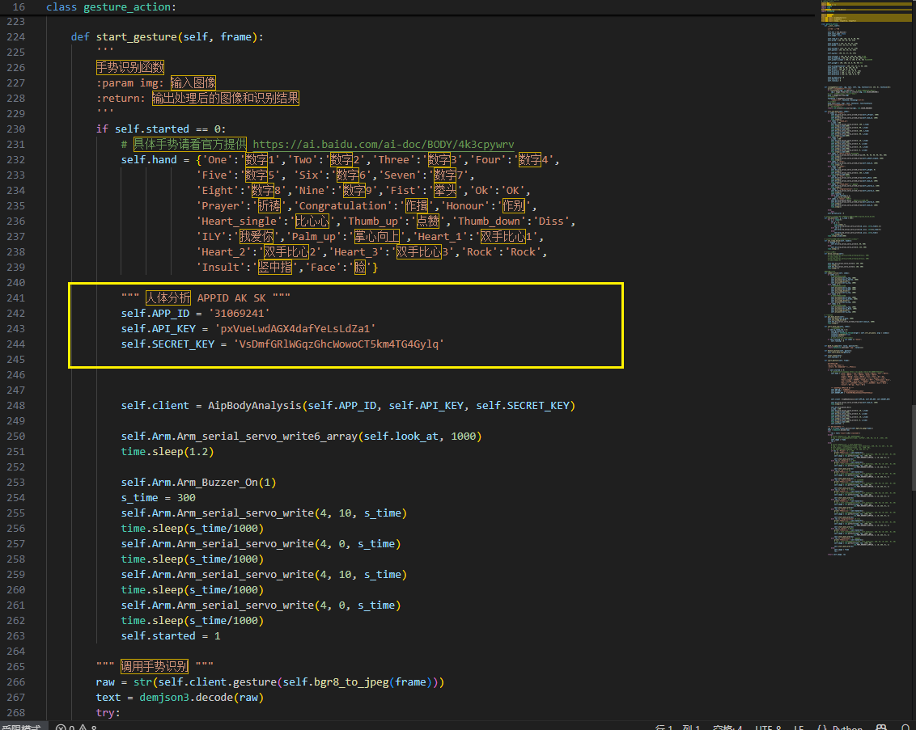

II.Modify the Baidu Gesture Recognition APP_ID details within the Gesture Recognition Stacking module.

1. Open the gesture stacking configuration file:
nano /home/jetson/colcon_ws/src/arm_gesture_stacking/gesture_stack.py

- Scroll down to locate the `Gesture_Action` function; find the section containing the APP_ID information and replace it with the Baidu ID details you have obtained. For instructions on how to apply for an ID, please contact technical support.
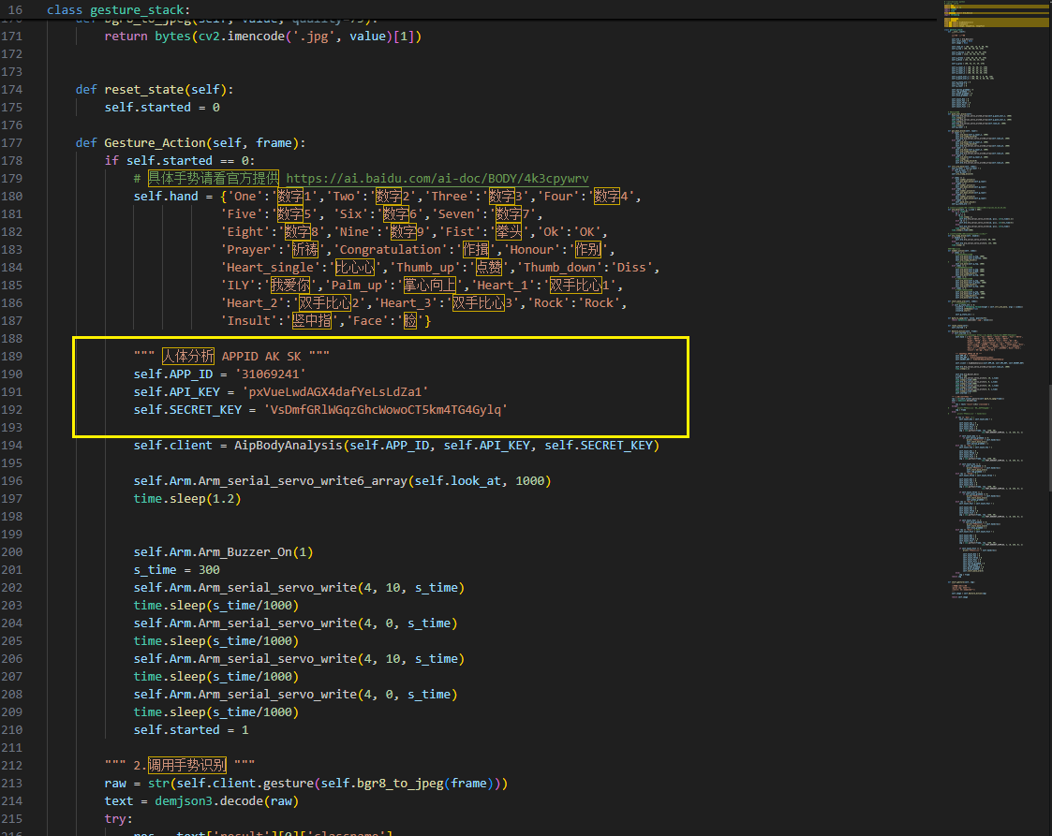
3. Press Ctrl+S to save, then press Ctrl+X to exit.

Note: Both files must be modified simultaneously to contain identical Baidu Gesture Recognition APP_ID information. Compilation is required after making these modifications.

